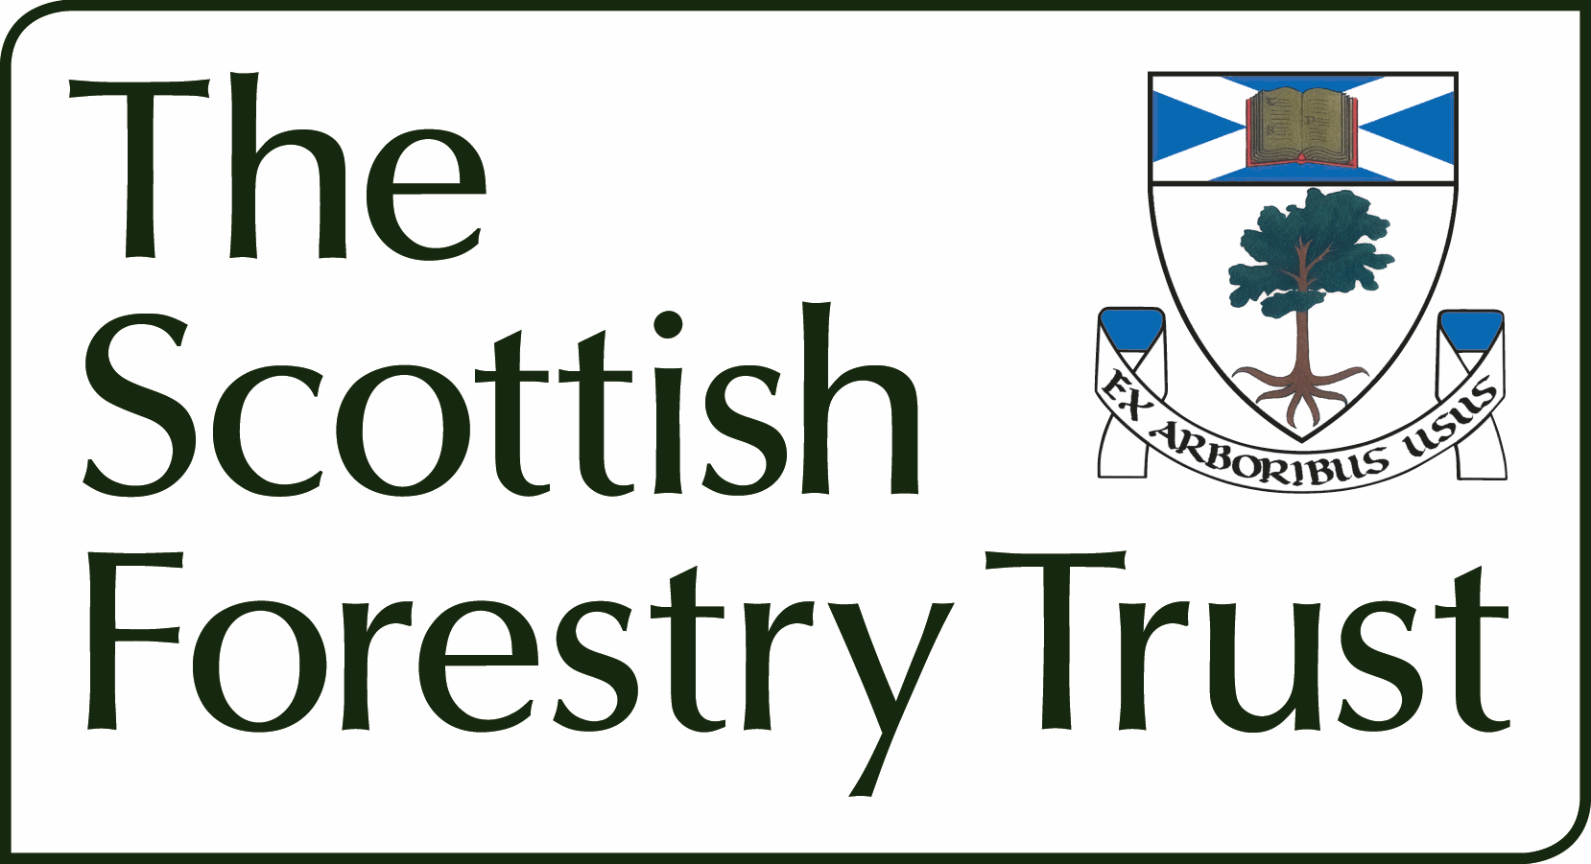

Support for travel costs and fieldwork expenses for Forestry and Arboriculture Masters courses in the UK

Application and Claim Form

Student Name:
Programme Title:
Higher Education Institution:
Start date for course:
Completion date for course:
Part-time or Full-time:

Purpose of the fieldwork/travel: (Please give a short description of the proposed study, and need for fieldwork and travel – 200 words max)

Costs: (Please answer the following)
What are the main elements and total cost of your fieldwork?
How much are you seeking from the SFT, bearing in mind the 50% or £300 limit?
How will the remainder be covered?

I confirm that I have read the terms of assistance applying to this request for funds and that I recommend the above student for an award of travel/fieldwork costs under this scheme.
Programme supervisor name:
Date:

I confirm that the above request for assistance is a necessary part of my course and that I will provide evidence of expenditure to support my claim after the travel/fieldwork has taken place.
Student name:
Email address:
Date:

This form should be sent to director@scottishforestrytrust.org.uk

